

AMERICAN INTERNATIONAL UNIVERSITY–BANGLADESH (AIUB)
Dept. of Computer Science
Faculty of Science and Technology
CSC2210: OBJECT ORIENTED PROGRAMMING 2
Summer 2025-2026
Section: [P]2

Project Report On
Project Name [Cinelog(letterboxd lite)]
Supervised By
AL JUBAIR HOSSAIN
Submitted By: MAHMUDUR RAHMAN
Name | ID
1. MAHMUDUR RAHMAN | 24-59694-3
2. SHAH ABU MUSA | 24-58378-2
3. MST. ANIKA TASNIM | 24-59005-3
4. MD ISHTIAQUE HOSSAIN | 24-57987-2
Obtained Marks for CO2 and CO4 (Description given in the following page)
Assessment  Criteria | Not Attended/ Incorrect (0) |  | Inadequate  (1-2) |  | Average  (3) | Good  (4) | Excellent  (5)
Evaluation Criteria (CO2) |  | Total = |  | Evaluation Criteria (CO4) |  |  | Total =
Requirement fulfillment |  |  |  | Design & Innovation
Validation |  |  |  | Teamwork & Ethics
Verification |  |  |  | Communication

CO2: Display and verify the mean of a real-life Project using the concepts of C# Graphical User Interface based environment with database integration to depict a desktop-based application.
Assessment  Criteria | Not Attended/ Incorrect (0) | Inadequate  (1-2) |  | Average  (3) |  | Good  (4) |  | Excellent  (5)
Evaluation Criteria | Evaluation Definition
Requirement fulfillment | Fails to demonstrate any understanding of real-life scenario-based project development or functional requirement identification. There is no attempt to depict a project or identify functional requirements accurately. |  | Demonstrates limited understanding of real-life scenario-based project development and functional requirement identification. The project depicted lacks coherence or relevance to real-life scenarios, and functional requirements are inaccurately identified or insufficiently described. |  | Presents a basic depiction of a real-life scenario-based project and identifies some functional requirements. However, the project lacks depth or complexity, and some functional requirements may be vaguely defined or missing key details. |  | Effectively demonstrates a realistic scenario-based project and accurately identifies most functional requirements. The project is well-developed with appropriate complexity, and functional requirements are clearly articulated with relevant details. |  | Exhibits an exceptional understanding of real-life scenario-based project development and accurately identifies all functional requirements. The project is meticulously developed with thorough attention to detail, reflecting a comprehensive understanding of Object-Oriented Programming project development activities.
Validation | Fails to demonstrate any understanding or implementation of validation forms in their system. There is no attempt to deal with data validation, and validation requirements are completely ignored or incorrectly applied. |  | Demonstrates limited understanding of validation forms and data validation techniques. While some attempt may be made to implement validation, it is incomplete or poorly executed, leading to inadequate handling of data validation. |  | Shows a basic understanding of validation forms and data validation techniques. They attempt to implement validation, but some aspects may be missing or incorrectly implemented, resulting in partial or inconsistent handling of data validation. |  | Effectively demonstrates the use of validation forms and implements data validation techniques. Validation is mostly accurate and comprehensive, ensuring the proper handling of data input and verification in the system. |  | Exhibits an exceptional understanding and implementation of validation forms and data validation techniques. Validation is meticulously implemented with thorough attention to detail, ensuring robust data validation procedures and contributing to the overall reliability and integrity of the system.
Verification | Fails to demonstrate any attempt to verify the system data or functional requirements. There is no evidence of understanding or implementation of verification processes, and data flow is not considered. |  | Demonstrates limited understanding of verification processes and data flow in the system. Verification attempts are incomplete or inaccurate, and there is insufficient consideration given to ensuring data integrity and functionality. |  | Shows a basic understanding of verification processes and attempts to verify system data. However, verification efforts may be inconsistent or lack thoroughness, and there may be gaps in ensuring proper functional requirements and data flow. |  | Identifies and verifies system data, ensuring proper functional requirements are met. Verification efforts are mostly accurate and thorough, with attention to ensuring data integrity and appropriate data flow within the system. |  | Exhibits an exceptional understanding of verification processes and meticulously verifies system data. Verification efforts are comprehensive and precise, with a keen focus on ensuring all functional requirements are met and maintaining proper data flow throughout the system.

CO4: Display and verify the mean of a real-life Project using the concepts of C# Graphical User Interface based environment with database integration to depict a desktop-based application.
Assessment  Criteria | Not Attended/ Incorrect (0) | Inadequate  (1-2) |  | Average  (3) |  | Good  (4) |  | Excellent  (5)
Evaluation Criteria | Evaluation Definition
Requirement fulfillment | Fails to demonstrate any attempt to perform or solve system functional requirements. There is no evidence of addressing real-life scenario-based projects or identifying functional requirements for Object-Oriented Programming project development activities. |  | Demonstrates limited understanding of system functional requirements and real-life scenario-based projects. Attempts to perform or solve functional requirements may be incomplete or inaccurately applied, and there is insufficient consideration given to proper identification of requirements. |  | Shows a basic understanding of system functional requirements and attempts to perform or solve them. However, the execution may lack depth or thoroughness, and there may be gaps in addressing all aspects of real-life scenario-based projects or properly identifying functional requirements. |  | Effectively demonstrates the performance and solution of system functional requirements for real-life scenario-based projects. Requirements are identified with clarity and relevance, and the execution is mostly accurate and comprehensive, reflecting a solid understanding of Object-Oriented Programming project development activities. |  | Exhibits an exceptional understanding of system functional requirements and adeptly performs and solves them for real-life scenario-based projects. Requirements are meticulously identified and executed with thorough attention to detail, showcasing a comprehensive mastery of Object-Oriented Programming project development activities.
Validation | Fails to demonstrate any understanding or implementation of validation forms or data validation techniques. There is no evidence of addressing validation requirements or dealing with data validation in their system. |  | Demonstrates limited understanding of validation forms and data validation techniques. While some attempt may be made to implement validation, it is incomplete or poorly executed, leading to inadequate handling of data validation. |  | Shows a basic understanding of validation forms and data validation techniques. They attempt to implement validation, but some aspects may be missing or incorrectly implemented, resulting in partial or inconsistent handling of data validation. |  | Demonstrates the use of validation forms and implements data validation techniques. Validation is mostly accurate and comprehensive, ensuring the proper handling of data input and verification in the system, although there may be minor issues. |  | Exhibits an exceptional understanding and implementation of validation forms and data validation techniques. Validation is meticulously implemented with thorough attention to detail, ensuring robust data validation procedures and contributing to the overall reliability and integrity of the system.
Verification | Fails to demonstrate any understanding or attempt to verify system data or functional requirements. There is no evidence of addressing verification requirements or considering data flow in their system solution. |  | Demonstrates limited understanding of verification processes and data flow in the system. Verification attempts may be incomplete or inaccurately applied, and there is insufficient consideration given to ensuring proper functional requirements and data flow. |  | Shows a basic understanding of verification processes and attempts to verify system data. However, verification efforts may lack thoroughness or precision, and there may be gaps in ensuring proper functional requirements and data flow within the system. |  | Effectively identifies and verifies system data, ensuring proper functional requirements are met. Verification efforts are mostly accurate and comprehensive, with attention to ensuring data integrity and appropriate data flow within the system. |  | Exhibits an exceptional understanding of verification processes and meticulously verifies system data. Verification efforts are comprehensive and precise, with a keen focus on ensuring all functional requirements are met and maintaining proper data flow throughout the system.

Table of Contents: Page no.

1. Chapter: 01 (Introduction)----------------------------------------------------------------------- 03
2. Chapter: 02 (User Story)------------------------------------------------------------------------- 03
3. Chapter: 03a (ER Diagram)---------------------------------------------------------------------- 05
4. Chapter: 03b (SQL Queries)--------------------------------------------------------------------- 06
5. Chapter: 04 (Screenshots)------------------------------------------------------------------------ 09

Introduction:

Cinleog(letterboxd) is a winfom app that works as a social media platform for movies. It has enormous amounts of features that useful for every cinema enthusiast. The app use c#, .net framework, mysql and tmdb api for its functionality. The app is not perfect but with its solid structure it’ll be much easier to implement further features and improvements.

User Story:

The user of the app will be able to create accounts, save information, customize their profile and also will be able to delete their accounts. The app will keep the user up to date for any genre of movies.

SQL Queries

USE cinelog;

-- ============================
-- Users
-- ============================
CREATE TABLE Users (
UserId INT AUTO_INCREMENT PRIMARY KEY,
Username VARCHAR(50) NOT NULL UNIQUE,
Email VARCHAR(100) NOT NULL UNIQUE,
PasswordHash VARCHAR(255) NOT NULL,
CreatedAt DATETIME NOT NULL DEFAULT CURRENT_TIMESTAMP
);

-- ============================
-- Movies (cached subset of TMDB data)
-- ============================
CREATE TABLE Movies (
MovieId INT AUTO_INCREMENT PRIMARY KEY,
TMDBId INT NOT NULL UNIQUE,
Title VARCHAR(255) NOT NULL,
ReleaseDate DATE NULL,
PosterPath VARCHAR(255) NULL,
BackdropPath VARCHAR(255) NULL,
Overview TEXT NULL,
Runtime INT NULL,
TMDBRating DECIMAL(3,1) NULL
);

-- ============================
-- Ratings (1 rating per user per movie)
-- ============================
CREATE TABLE Ratings (
RatingId INT AUTO_INCREMENT PRIMARY KEY,
UserId INT NOT NULL,
MovieId INT NOT NULL,
Rating TINYINT NOT NULL CHECK (Rating BETWEEN 1 AND 5),
RatedAt DATETIME NOT NULL DEFAULT CURRENT_TIMESTAMP,
FOREIGN KEY (UserId) REFERENCES Users(UserId) ON DELETE CASCADE,
FOREIGN KEY (MovieId) REFERENCES Movies(MovieId) ON DELETE CASCADE,
UNIQUE KEY unique_user_movie_rating (UserId, MovieId)
);

-- ============================
-- Reviews (a user can leave one review per movie)
-- ============================
CREATE TABLE Reviews (
ReviewId INT AUTO_INCREMENT PRIMARY KEY,
UserId INT NOT NULL,
MovieId INT NOT NULL,
ReviewText TEXT NOT NULL,
CreatedAt DATETIME NOT NULL DEFAULT CURRENT_TIMESTAMP,
FOREIGN KEY (UserId) REFERENCES Users(UserId) ON DELETE CASCADE,
FOREIGN KEY (MovieId) REFERENCES Movies(MovieId) ON DELETE CASCADE
);

-- ============================
-- Watchlist ("want to watch")
-- ============================
CREATE TABLE Watchlist (
WatchlistId INT AUTO_INCREMENT PRIMARY KEY,
UserId INT NOT NULL,
MovieId INT NOT NULL,
AddedAt DATETIME NOT NULL DEFAULT CURRENT_TIMESTAMP,
FOREIGN KEY (UserId) REFERENCES Users(UserId) ON DELETE CASCADE,
FOREIGN KEY (MovieId) REFERENCES Movies(MovieId) ON DELETE CASCADE,
UNIQUE KEY unique_user_movie_watchlist (UserId, MovieId)
);

-- ============================
-- WatchHistory (diary entries — a movie can be watched more than once)
-- ============================
CREATE TABLE WatchHistory (
HistoryId INT AUTO_INCREMENT PRIMARY KEY,
UserId INT NOT NULL,
MovieId INT NOT NULL,
WatchedDate DATE NOT NULL,
FOREIGN KEY (UserId) REFERENCES Users(UserId) ON DELETE CASCADE,
FOREIGN KEY (MovieId) REFERENCES Movies(MovieId) ON DELETE CASCADE
);

-- ============================
-- MovieLists (custom lists, e.g. "Best Sci-Fi")
-- ============================
CREATE TABLE MovieLists (
ListId INT AUTO_INCREMENT PRIMARY KEY,
UserId INT NOT NULL,
ListName VARCHAR(100) NOT NULL,
Description VARCHAR(255) NULL,
CreatedAt DATETIME NOT NULL DEFAULT CURRENT_TIMESTAMP,
FOREIGN KEY (UserId) REFERENCES Users(UserId) ON DELETE CASCADE
);

-- ============================
-- ListMovies (movies inside a custom list)
-- ============================
CREATE TABLE ListMovies (
ListMovieId INT AUTO_INCREMENT PRIMARY KEY,
ListId INT NOT NULL,
MovieId INT NOT NULL,
AddedAt DATETIME NOT NULL DEFAULT CURRENT_TIMESTAMP,
FOREIGN KEY (ListId) REFERENCES MovieLists(ListId) ON DELETE CASCADE,
FOREIGN KEY (MovieId) REFERENCES Movies(MovieId) ON DELETE CASCADE,
UNIQUE KEY unique_list_movie (ListId, MovieId)
);

ER Diagram, Activity diagram:
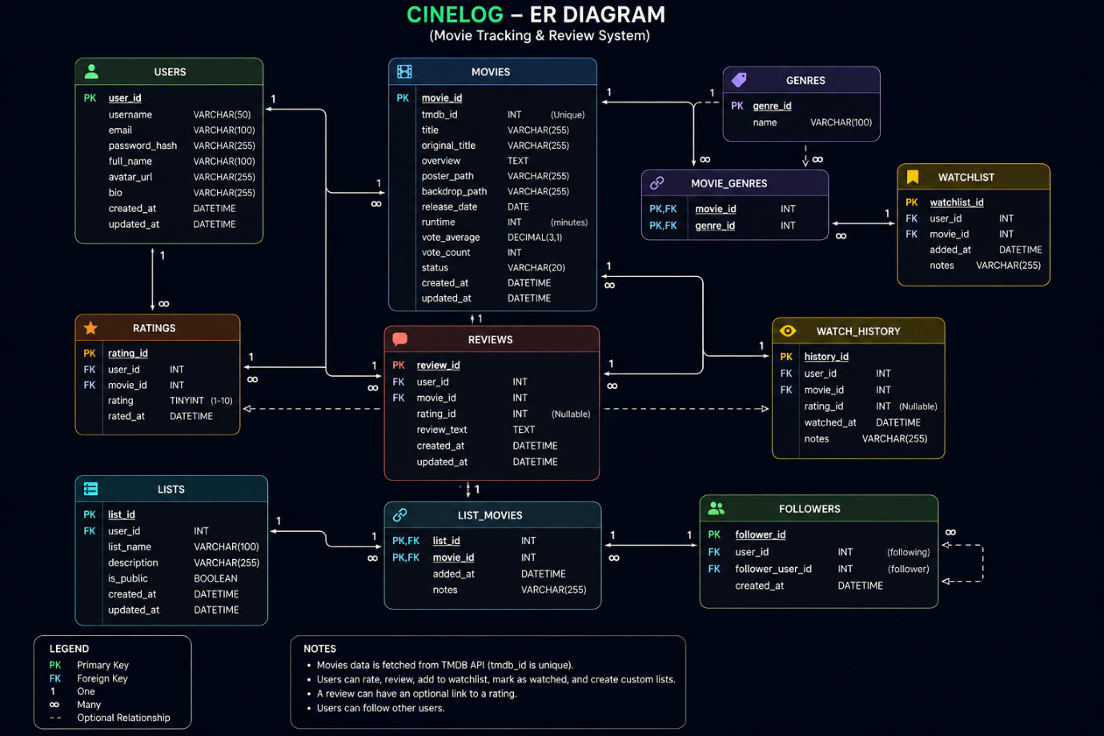
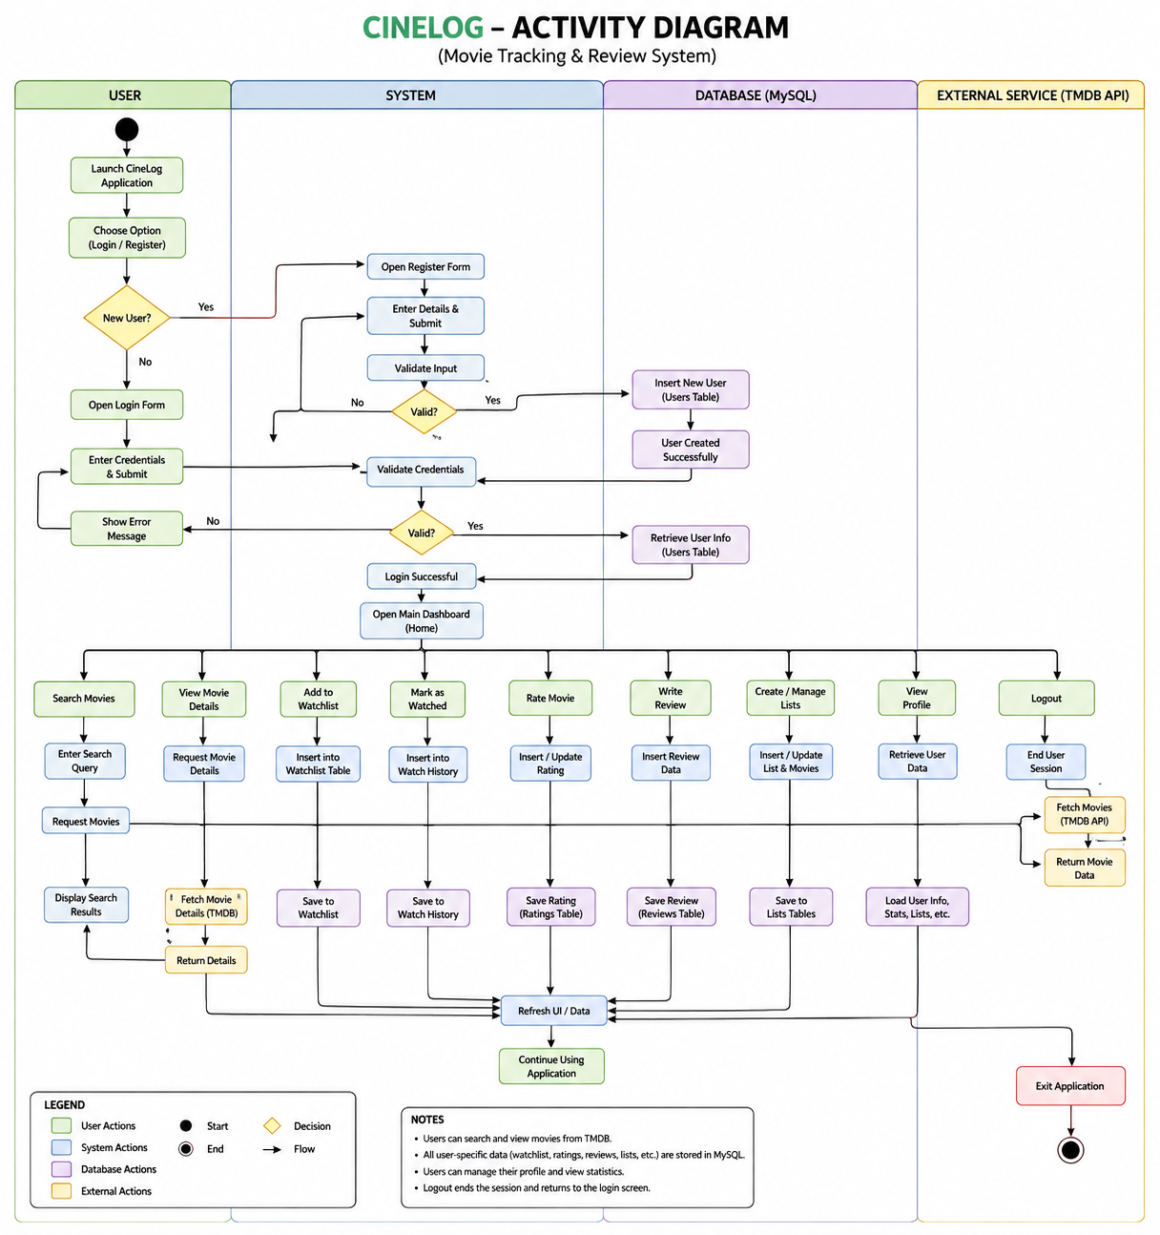
Screenshots of The app:
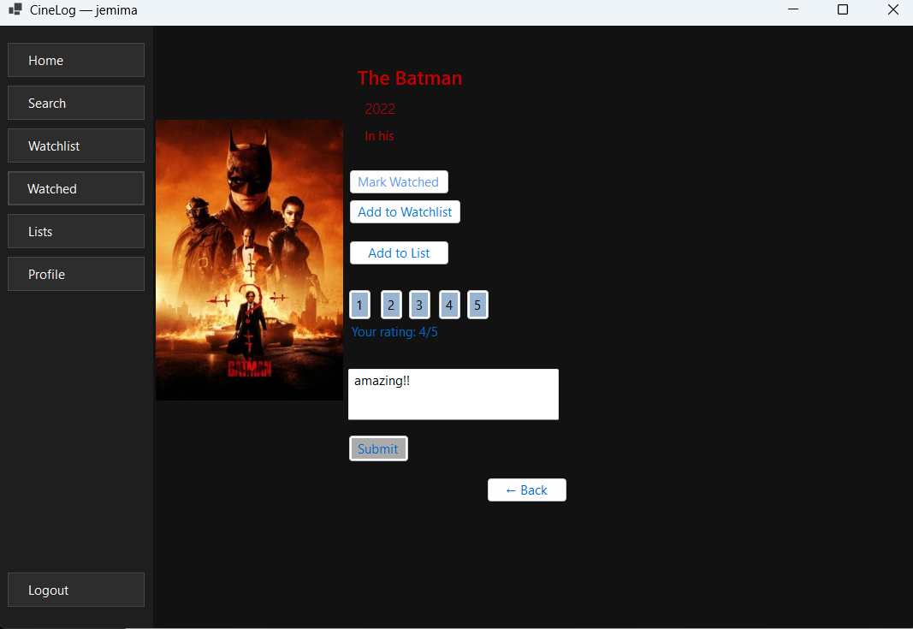
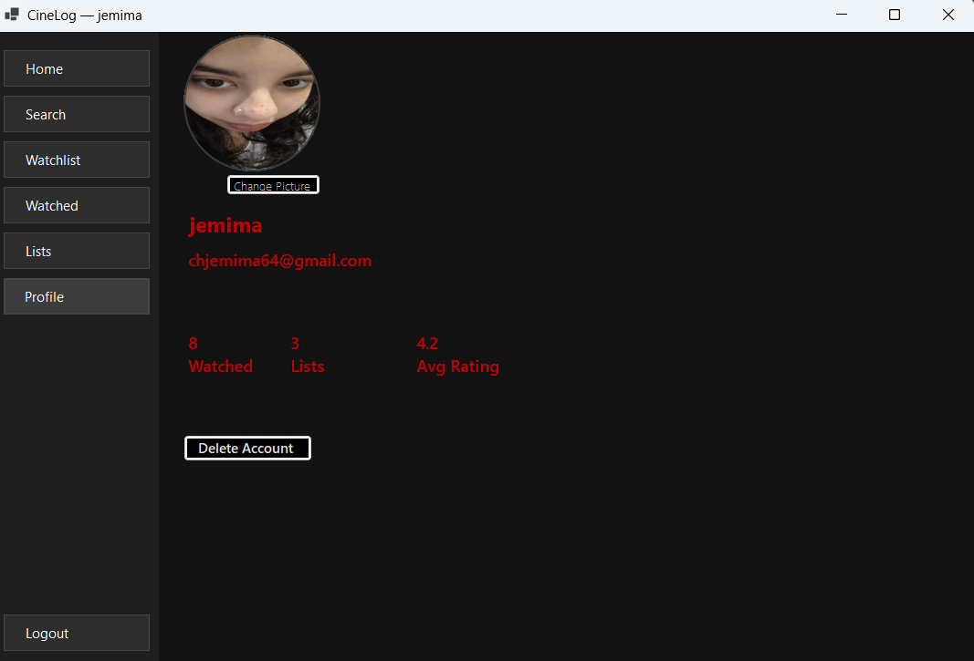

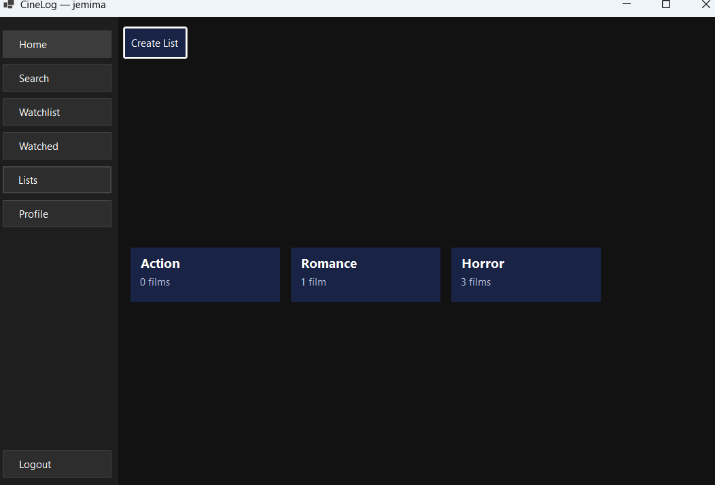
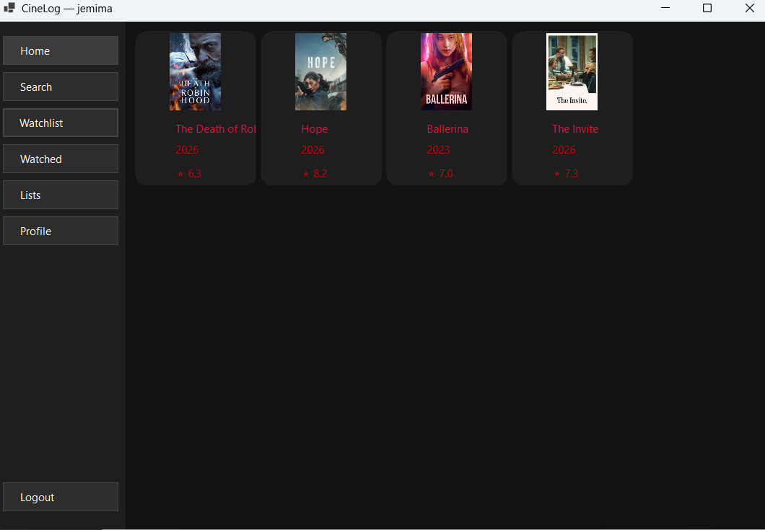
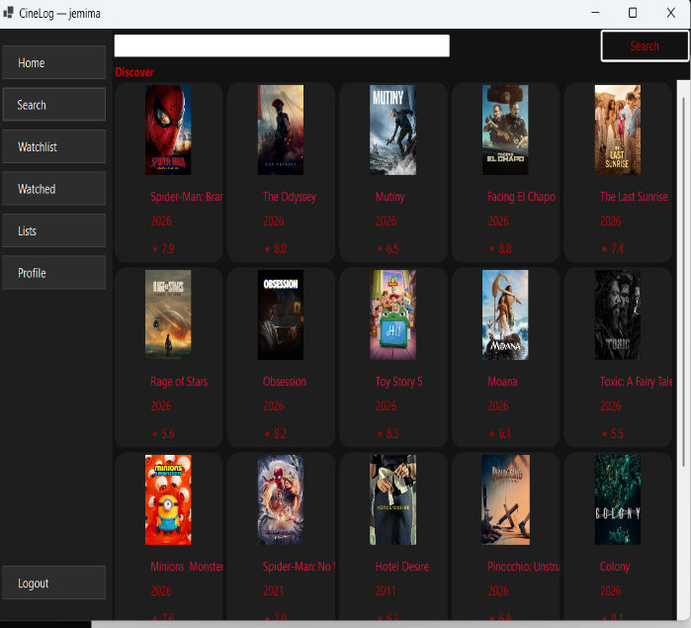
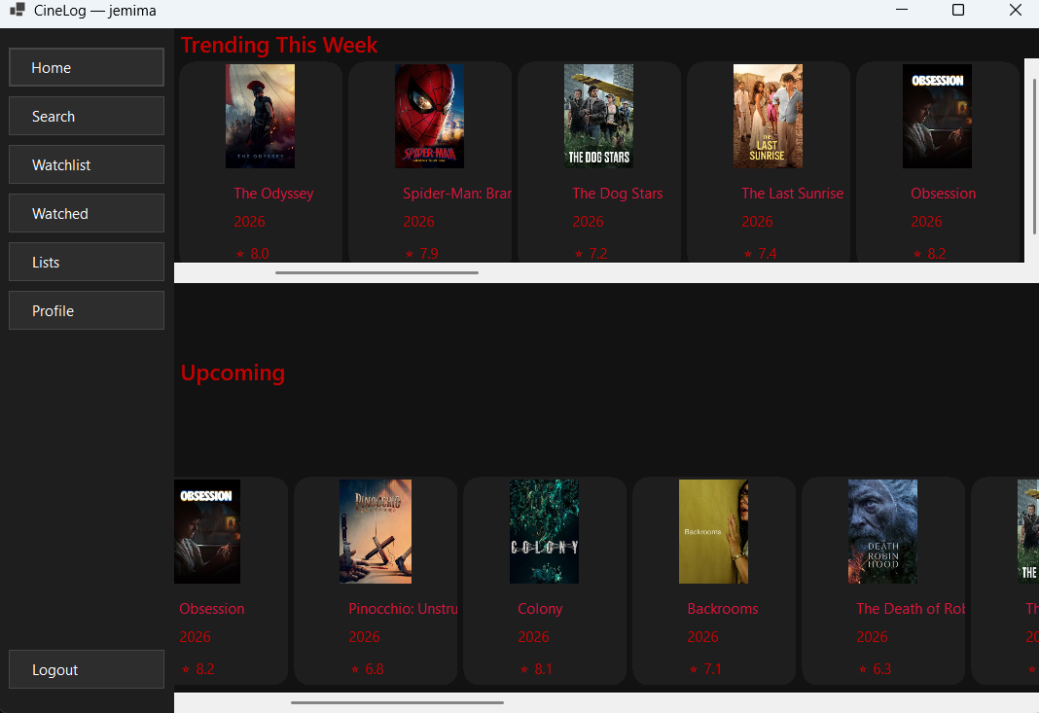
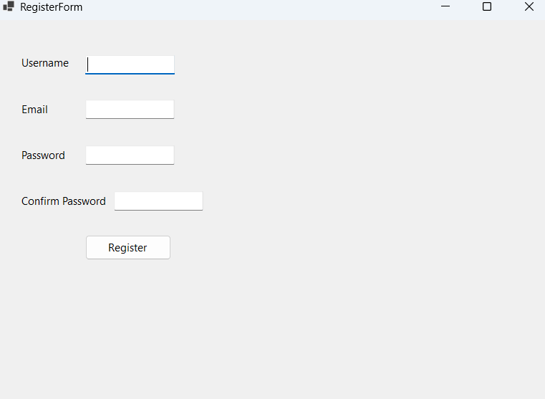
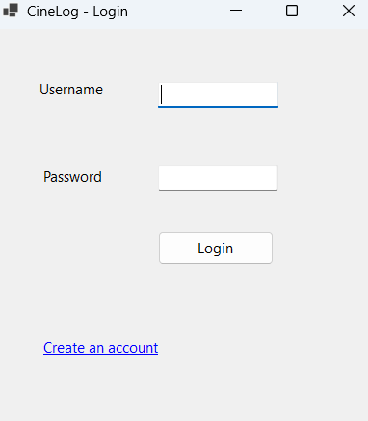

Conclusion:

Cinelog is user friendly movie social system that has potential to become an actual industry level product although it needs to be polished way further with richer and diverse tech stacks and its reliable and organized code structure it wont be a problem at all.

